internal report

control of an oscilloscope "tektronix tds210" and
of a robot "microcontrole it6dca" using the software
interface SICL and the bus IEEE488 using matlab

experimental setup

The experimental setup is composed of :

- a digital oscilloscope tektronix tds210 provided of a IEEE 488 interface
- a robot microcontrole it6dca1
- a robot microcontrole it6dca2
- a personal computer ibm thinkpad 560z
- a ines ieee 488 card

The sicl driver must be installed and configured properly. Hereafter it is shown the configuration of the sicl software interface :

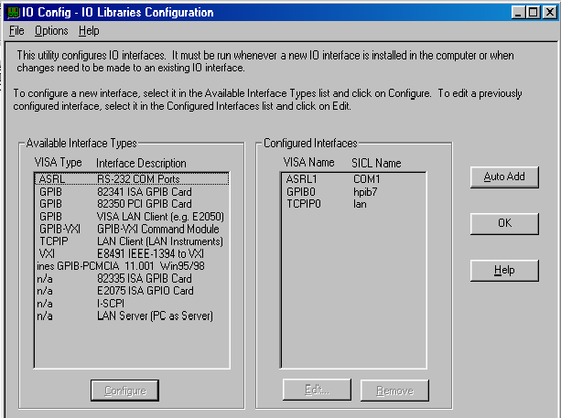

The instruments must be connected to the personal computer through the ieee488 bus. The address which have been assigned are :
tektronix tda210 | 7
microcontrole it6dca1 | 8
microcontrole it6dca2 | 9
The gpib interface of oscilloscope must be set as follows (menu utilitaire → options → configuration du bus gpib) :
Adresse | 7
Connexion du bus | parl./écout

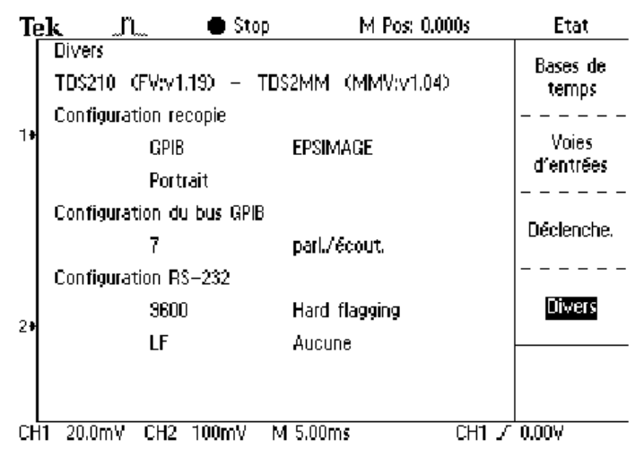

On the panel of the robots, the indicating light local distance must be turned on in order to enable the controller to receive commands from the bus ieee 488.

compiler enviromnent setup

The available drivers will work only with the compiler borland C version 5.5. Moreover, matlab must also be configured in order to be able to compile the mex-files. To this aim, the following procedure must be executed :
- unpack the compiler borland C in the directory c:\borland. The sicl libraries and include files are already comprised in this distribution. The compiler can be also found on the internet as a freeware software : in this case one mast take care of copying the sicl libraries and include files in the right directories.
- launch matlab and execute the mex configuration utility (mex –setup) specifying as compiler borland C version 5.3 (the version 5.5 is not proposed, but luckily it works!).
- copy the file mexopts.bat to the working directory, and add "by hand" the option :
–l bcsicl32.lib
- This option is needed to allows the linker to find the sicl library. A ready-to-use of the option file is also available.

arm placement calibration

The position of the arm with respect to the coordinates system of the appliance has been measured for the three orientation of the flux density sensor. The measurement has been done by putting a thin copper film on the surface of the coil, and then moving the arm to the reference position, which is determined by an iron vertical bar. The contact between the coil and the iron bar can be easily detected using a multimeter to check if there is a short-circuit between the bar and the copper film. The accuracy achieved is limited by the mechanical behaviour of the arm, and it is less than 1 mm. The formulas which give the position of the centre of the coil with respect of the arm coordinates system are (in [mm]) :

orientation x | x' = x + (91.7 + 13.0/2)  y' = y + (260.0 + 13.0/2)  z' = z + (102.4 - 206.0 – 26.0/2)
orientation y | x' = x + (154.9 + 13.0/2)  y' = y + (226.2 + 13.0/2)  z' = z + (102.4 - 206.0 – 26.0/2)
orientation z | x' = x + (141.6 + 26.0/2)  y' = y + (261.2 + 26.0/2)  z' = z + (151.29 - 206.0 - 13.0/2)

being (x, y, z) the cordinates with respect of the appliance, and (x', y', z') the coordinates with respect of the arm.

gpibwrite

name | gpibwrite
description | This function opens a channel toward an instrument, writes a string and closes the channel.
input | dev_id  buff  term_chr | string which identifies the instrument  string to be sent to the instrument  terminating char (optional)
output | *
see also | gpibwriteln(.)
warning | Most of instrument needs that command lines end with a line-feed. In this case is wiser to use the function gpibwriteln(.)  If the wrong terminating character is fed to this function, the computer and the instrument will not be able to communicate. I this case, no error message will be returned, but the command will have no effect.
example | gpibwrite ('hpib7,9', 'IIO', 10);
gpibwriteln

name | gpibwriteln
description | This function opens a channel toward an instrument, writes a string followed by a line-feed ('\n'), and closes the channel.
input | dev_id  buff  term_chr | string which identifies the instrument  string to be sent to the instrument  terminating char (optional)
output | *
see also | gpibwrite(.)
warning | If the wrong terminating character is fed to this function, the computer and the instrument will not be able to communicate. I this case, no error message will be returned, but the command will have no effect.
example | gpibwriteln ('hpib7,9', 'IIO', 10);
gpibreadln

name | gpibreadln
description | This function opens a channel toward an instrument, writes a string followed by a line-feed ('\n'), waits for the answer of the instrument, and closes the channel.
input | dev_id  buff  term_chr | string which identifies the instrument  string to be sent to the instrument  terminating char (optional)
output | answer | answer of the instrument
see also | gpibwrite(.), gpibwriteln(.)
warning | If the wrong terminating character is fed to this function, the computer and the instrument will not be able to communicate, and the program will hang.
example | answer = gpibreadln ('hpib7,9', 'C2?', 10);

gpib, or hp-ib are synonymous with ieee 488
The c programs can be compiled only within a certain directory, in that a specially modified configuration file has to be used.

